CURRICULUM VITAE
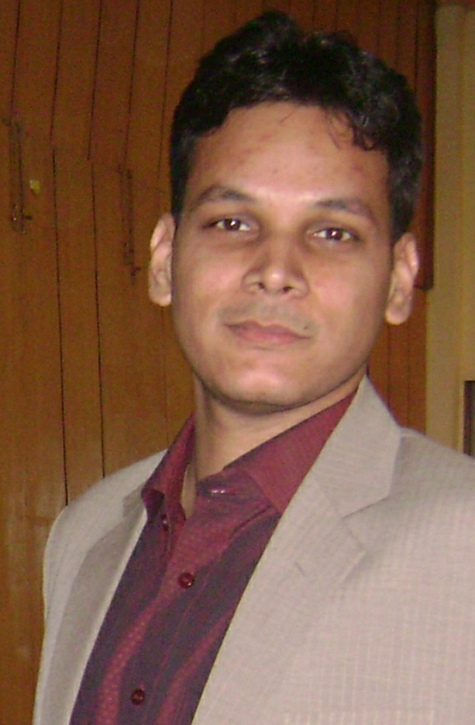 | Gaurav Singh  5\323 Viram Khand  Gomti Nagar Lucknow  Mob – 9453016825  togauravsinghi.t@gmail.com

OBJECTIVE:

To pursue a challenging career in academic / software development and to contribute proactively, thereby enabling the growth of the company and myself.

ACADEMICS:

i). Professional Qualification:
  - Master in Computer Application (MCA) in 2005-08 with 63% marks from Bundelkhand University, Jhansi, Uttar Pradesh.
  - Graduation (BSC – IT) in 2002-05 with 61% marks from Bundelkhand University, Jhansi, Uttar Pradesh.

ii). Educational Qualification:
  - 12 th with 59% marks (Hindi, English, Physics, Chemistry, Math) in 2002.
  - 10th with 50% marks (Hindi, English, Math, Physic, Chemistry, Social Science) in 1998.

COMPUTER PROFICIENCY

Language | Core Java, JSP, SERVLET , JDBC, VB6.0, C and C++
Web Development | HTML, JavaScript, DHTML, XML
Frame Works | Struts1.1, Tiles, Validator
RDBMS & DBMS | Mysql and My-Access
Web Servers & Application Servers | Apache Web Server, Tomcat 5.0.28
Operating System | Windows 98/2K/XP
IDE | My Eclipse 5.1.1
Designing Tools | Rational Rose

PROJECTS:

1. On Line Grievance Handling System

Details: This is an online grievance system for Municipal Corporation. This system handles the complaint of ordinary citizens to Municipal Corporation. This system has functionality to register as a complainant on the system. After register on the system user login and use the functionality of the system such as register complaint, maintain his/her profile etc. Another part of this system is to provide grievance to these users. Which handle by the controller (Municipal Corporation) of this system, they have certain set of tasks like update the status of complaint etc.
Duration: - 6 months.
Development Platform: My Eclipse, Core Java, Struts, JSP, Tomcat 5.0.28 Application Server, and Linux
My Role: As a project trainee I worked on website design and on small modules.

2 – Personal Information System Management:

Details: This system is developed to maintain personal information of members of organization, institution etc. This system is able to contain all personal and professional information of member. In this system user can add, get detail, list of members, edit or delete information.
Duration: - 4 Months
Development Platform: VB6.0 and MS-ACCESS
My Role: Information Gathering.

Experience:
- Apprenticeship and back end support in Java, asp and .net from 2008-10.
- Software Engineer, MNC at Sector-63, Noida from 2011 to 2012.
- Software Developer, Clavis Technologies Pvt. Ltd., G-32, First Floor, Sector - 63, Noida 201 301, from May' 2012 to Nov' 2013.
- Senior Software Developer, Clavis Technologies Pvt. Ltd., G-32, First Floor, Sector - 63, Noida 201 301, from Dec’ 2013 to Mar’2014.

Package:
Salary as Sr. Software Developer in Clavis Technologies at Noida was: Rs. 3.6 lacs / per year.

PERSONAL DETAILS:

My Strength : Goal oriented, Hard working, Motivating and Self-reliable.
My hobbies/interest : Social service, Playing cricket, Listening music.
Languages Known : Hindi, English
Date of Birth : 16th October 1981
Father’s Name : : Shri. Bharat Raj Singh
Permanent Address : Gomti Nagar, Lucknow - 226010
Phone : 0522 – 2725825

DECLARATION

I hereby declare that the information furnished above is true to the best of my knowledge.

Place: Lucknow
(GAURAV SINGH)
Date:

