Prof. Bharat Raj Singh (b. 1947, Sultanpur, Uttar Pradesh) is a distinguished academician, inventor, and thought leader in sustainable energy, environmental science, and mechanical engineering. His pioneering work has been globally recognized, with one chapter in the U.S. High School Curriculum since-2014 (Can Glacier & Icemelt be Reversed?) and another two chapters featured in NASA’s Glaciers Melting and Climate Change.

Education: B.Sc., Allahabad University (1967); B.E. Mechanical, SVNIT Surat (1972); M.E. Design & Analysis, MNNIT Allahabad (1988); Ph.D., GBTU Lucknow (2011).

Professional Journey: With over five decades of service, Prof. Singh spent 32 years in government organizations, retiring as Managing Director, U.P. Rajkiya Nirman Nigam, and 21 years in academics. He is presently Director General (Technical), School of Management Sciences, Lucknow.

Research & Innovation: Globally acclaimed for the Air-O-Bike, a compressed-air motorcycle featured in the Limca Book of Records (2014), he holds patents on Rotary and Vane Type Air Engines and leads path-breaking studies in zero-pollution energy systems.

Awards: Governor’s Award (1965), Best Officer (1981), Samaj-Shri National Award (2004), Best Professor Award (AKTU, 2018), and 3-times Limca Records for innovations, global warming and climate-change awareness.

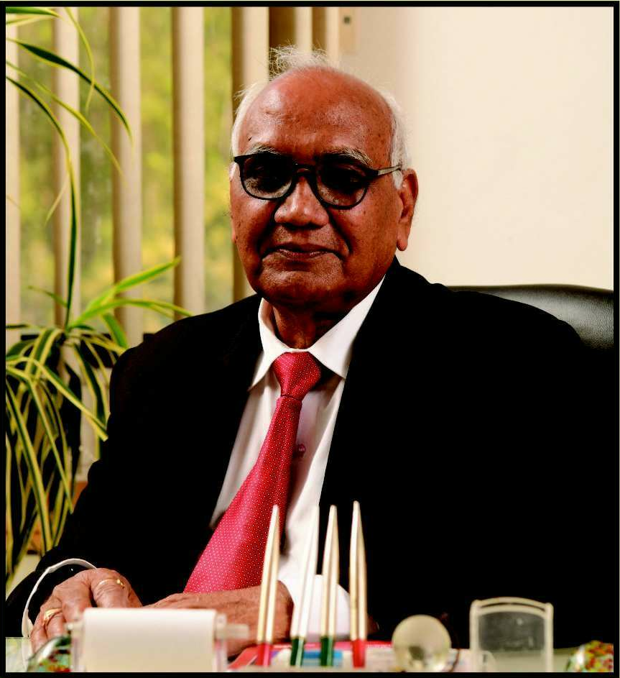
Publications & Leadership: Author of 25 books, 29 chapters, and 159 research papers, he serves on the boards of 55 international journals.

Affiliations: Fellow, Institution of Engineers (India)-1985, Chairman, IEI, UP State Centre & Council Member (2016–18, 2025-26); Member, IAENG; Chairman, Vedic Science Centre and C.V. Raman Centre for Research & Innovation.

A visionary dedicated to sustainable technologies and environmental stewardship, Prof. Singh continues to inspire global innovation and is poised to create a lasting impact at IEI.

